Anis Afiana (FS-B)

Hasil screenshot Insomnia Tugas 8

**Category**

Get Categories

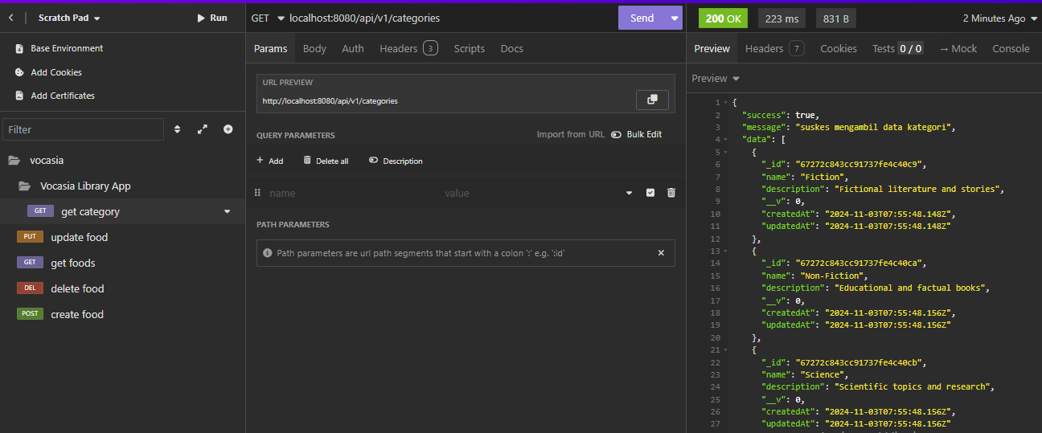

Get category by id

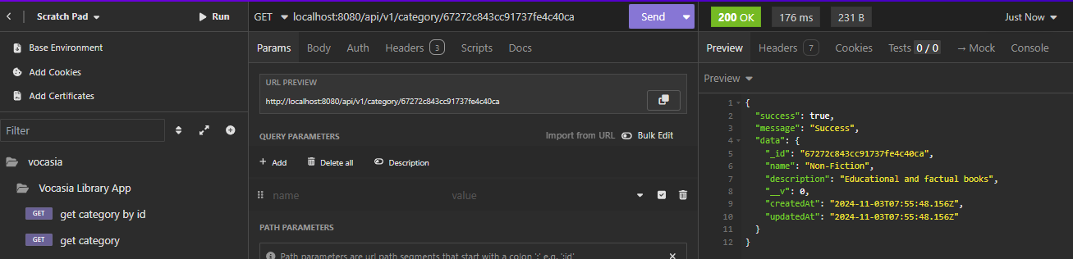

Create category

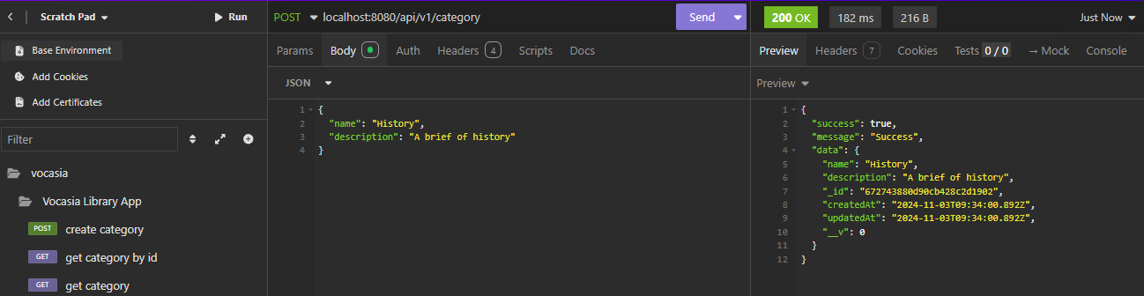

Update category

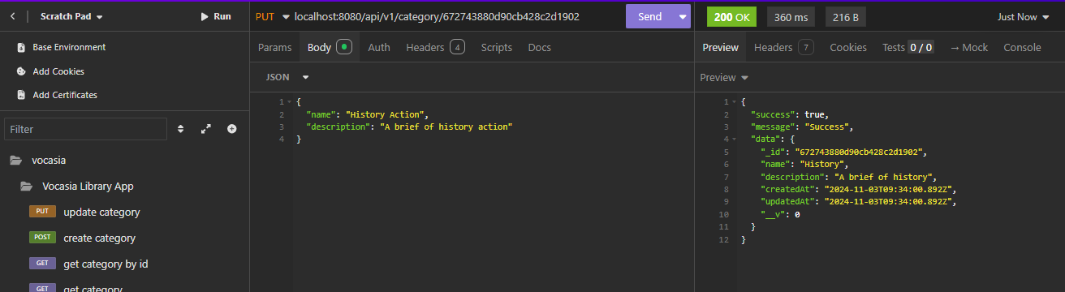

Delete category

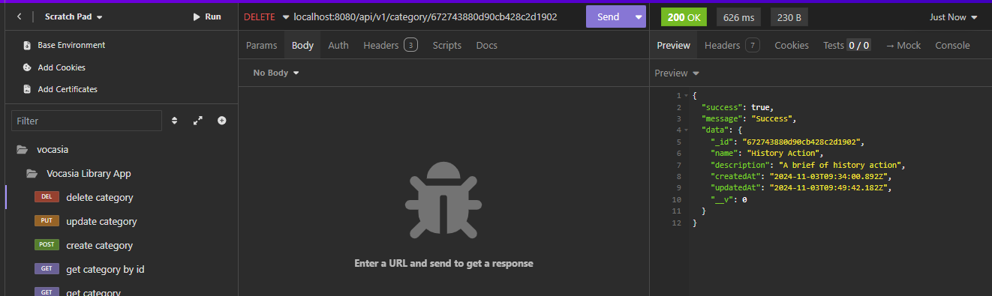

**Book**

Get Books

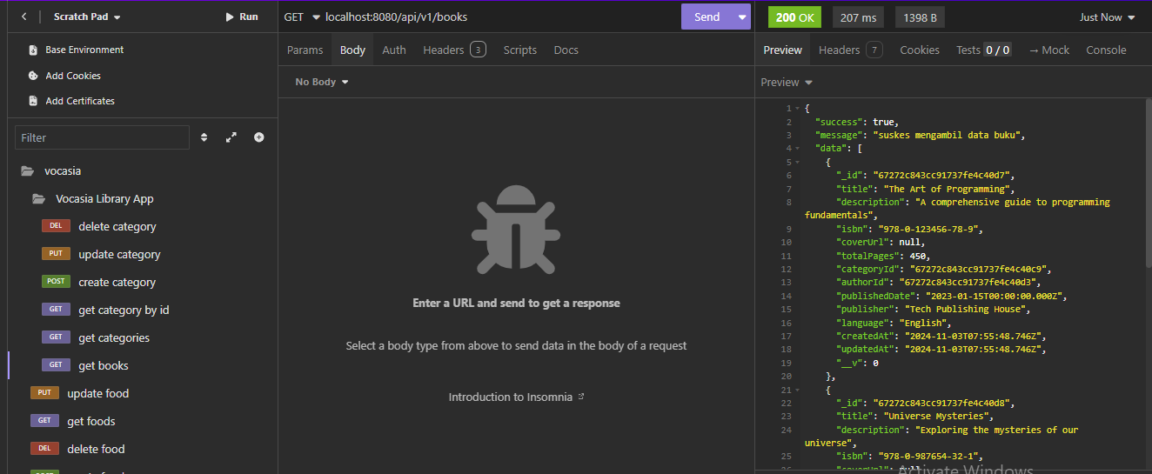

Get book detail By id

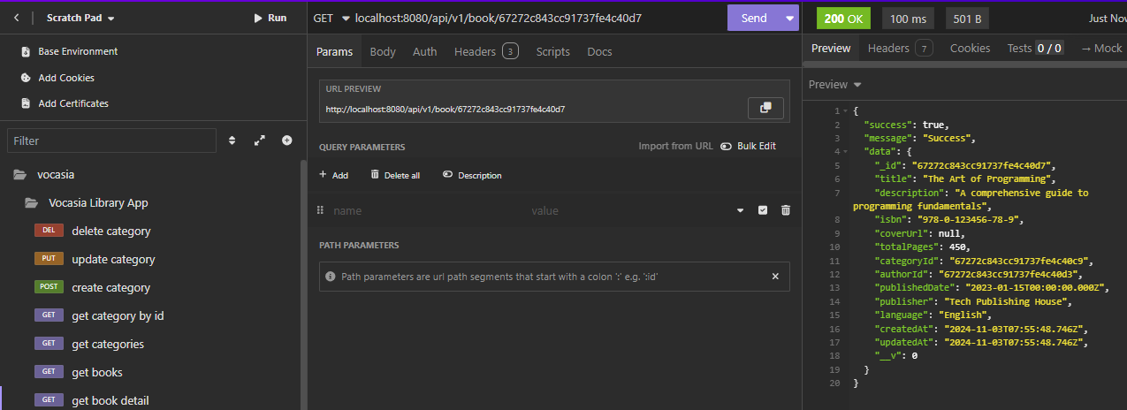

Get books with category name, description && author name, bio

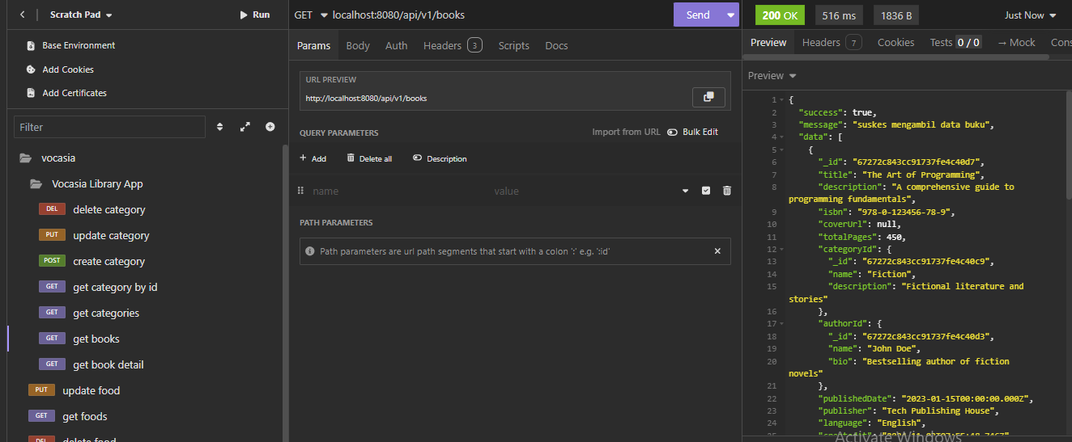

Get book detail by id with populate category & author name

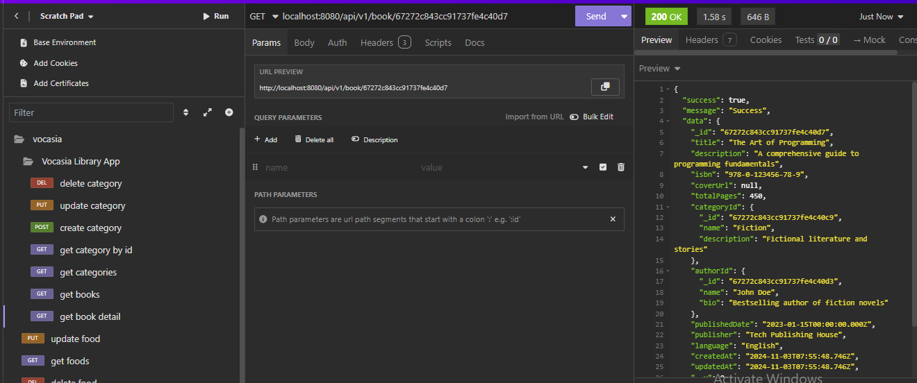

Upload image cover book

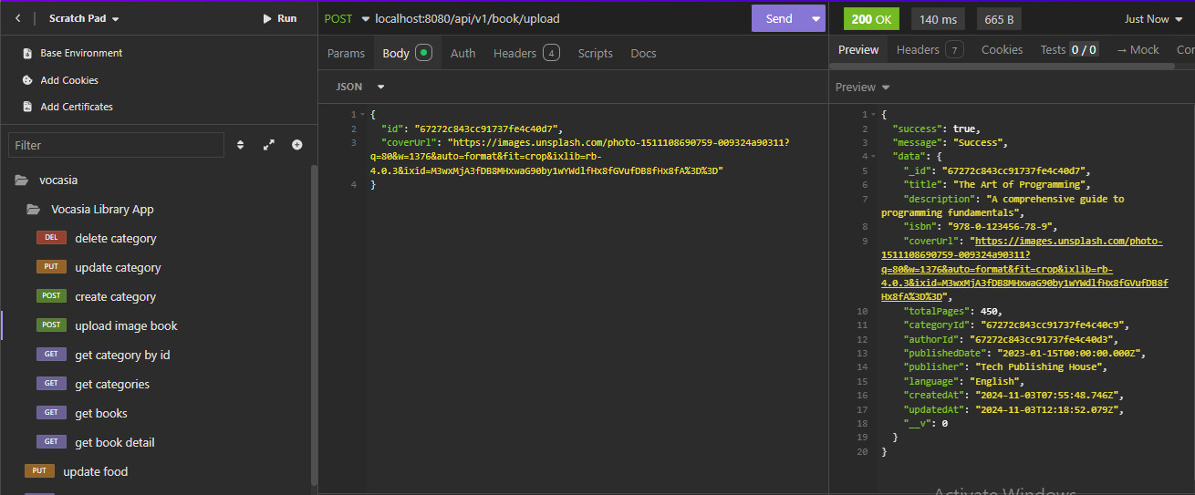

Create new data book

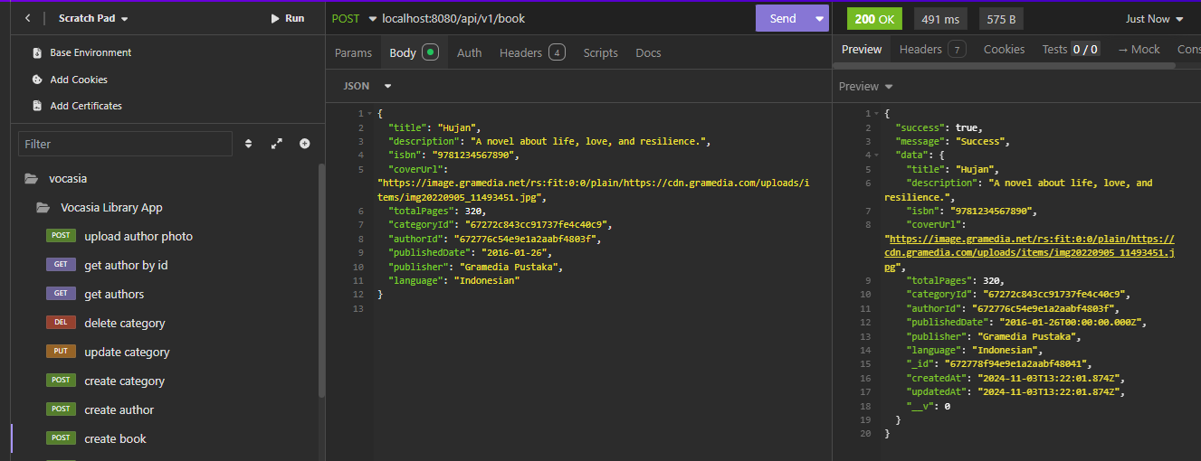

**Author**

Get authors with title of books

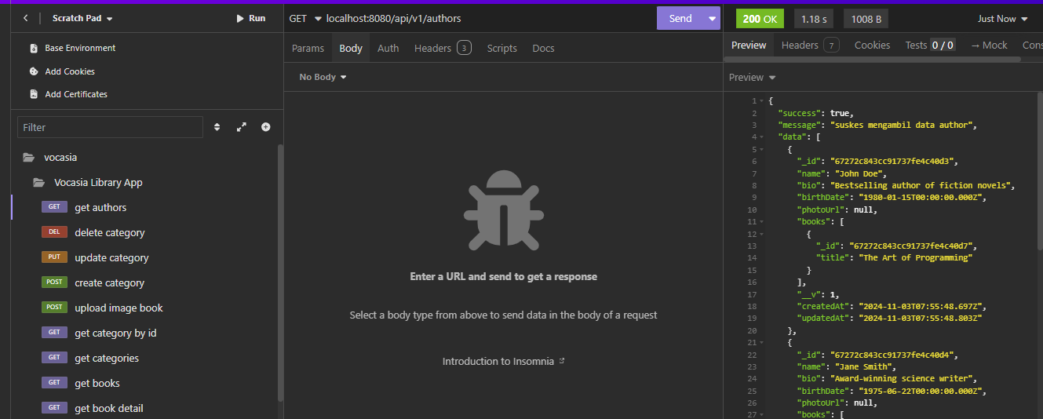

Get author by id with title of books

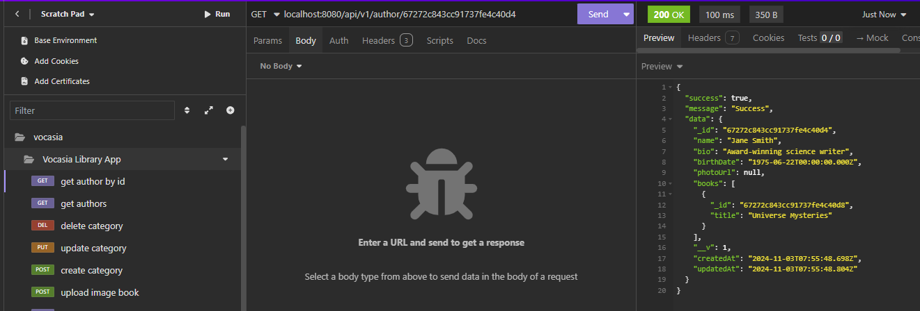

Create author

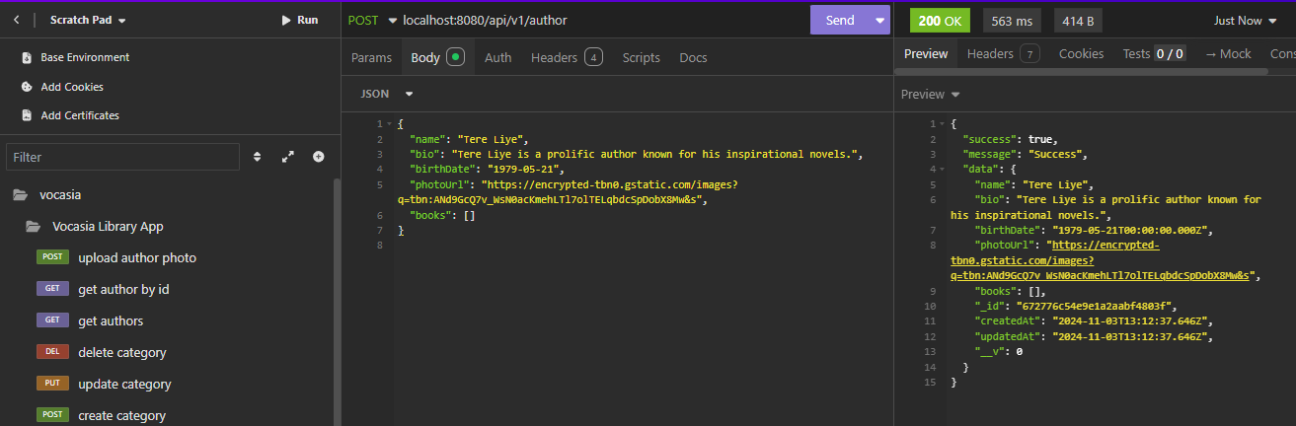

Upload foto author

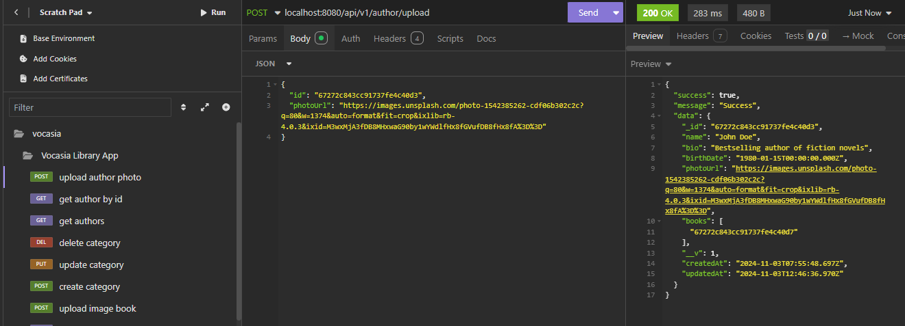

**Borrower**

Get borrowers

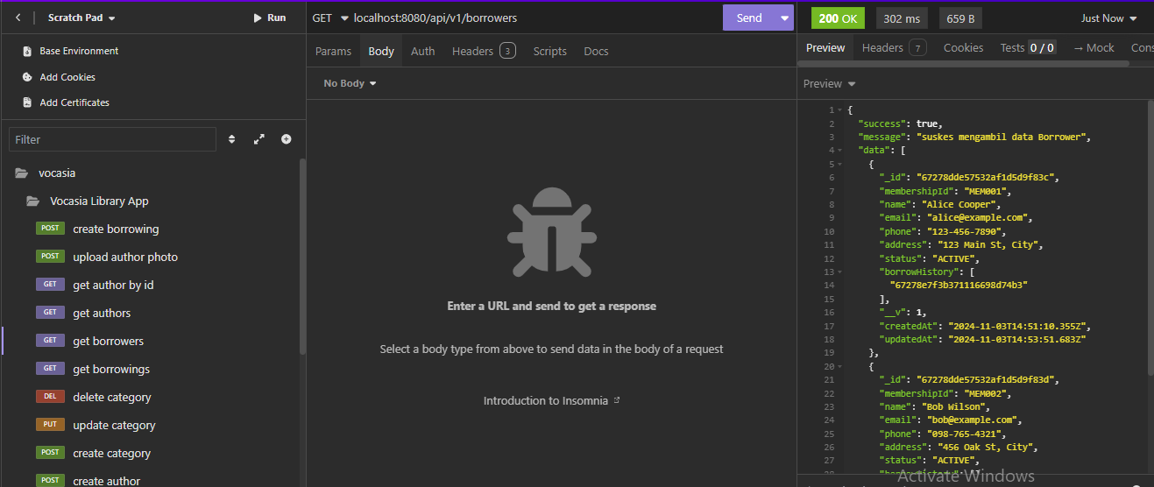

Get borrower by id

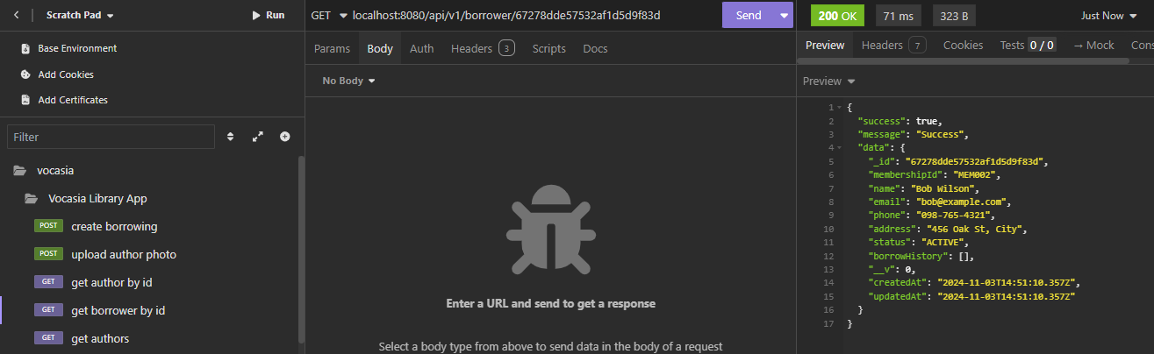

**Borrowing**

Create borrowing

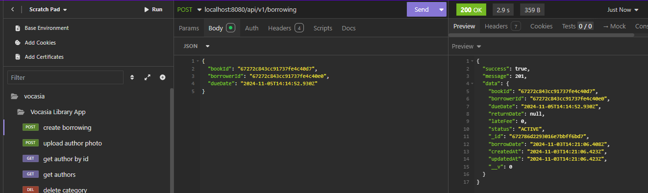

Get borrowings

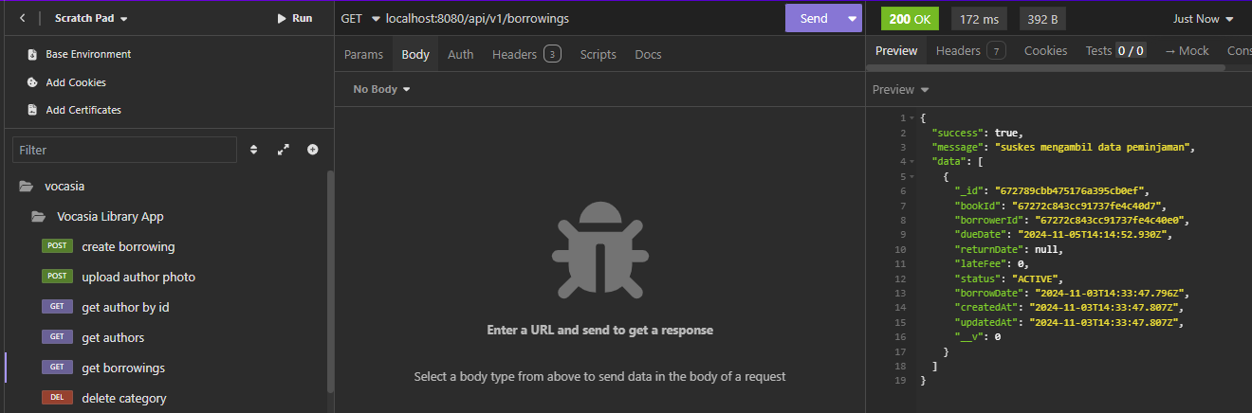

Get borrowing with populate book & borrower id

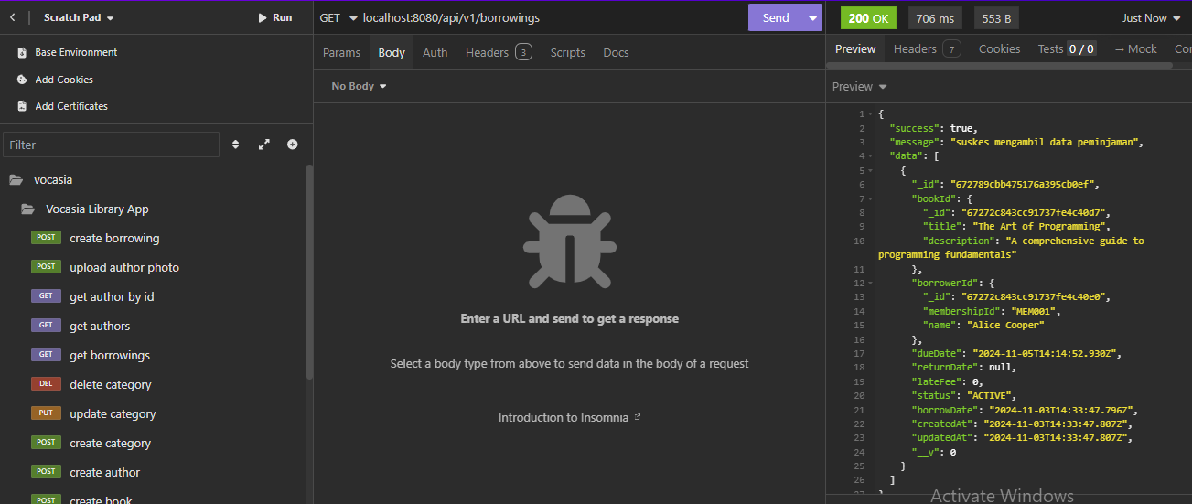

Return borrowing

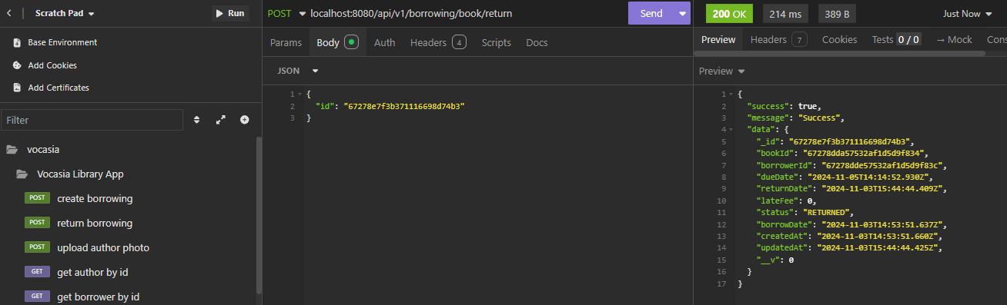

Di borrowing list

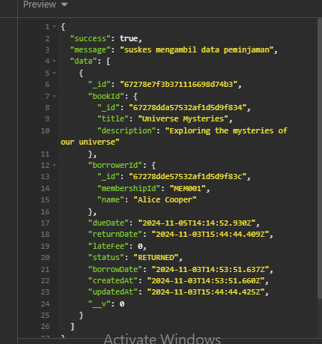 returned

Memakai filter ‘returned’

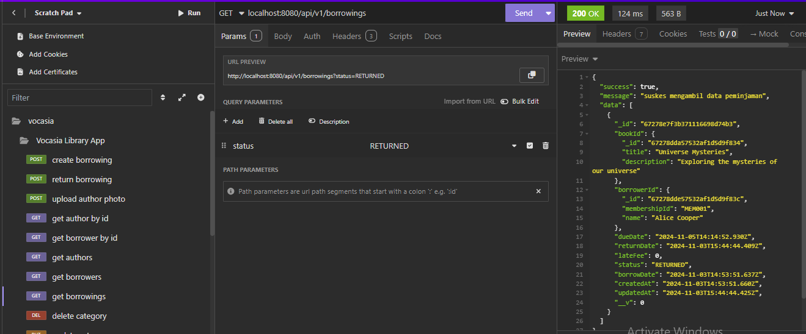

Memakai filter ‘active’

